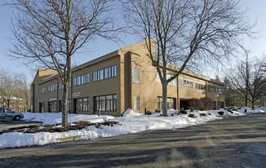

First Connections
179 Great Road, Suite 104A
Acton, MA 01720
In the Patriot Square Office Building
http://binged.it/1LkyZ1y
Phone: 978-429-8284

Enter from the right side of the building (visible above).
Inside the building, enter the 2nd door on your right
on the ground floor.

There is free parking all around the building.

Strawberry #179 Trader Joe’s
Hill Rd Patriot Sq. Plaza
Intersection Route
with (Route 2A/119/Great Road) 2
Route 27_______________________________________________________________ Rotary_
Donelans’ Colonial Dunkin’ Concord
Plaza Chevrolet Donuts Road

