April
2018 | 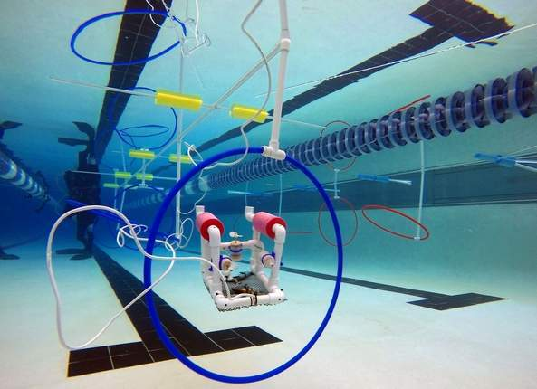

Sunday | Monday | Tuesday | Wednesday | Thursday | Friday | Saturday
1 | 2 | 3 | 4 | 5 | 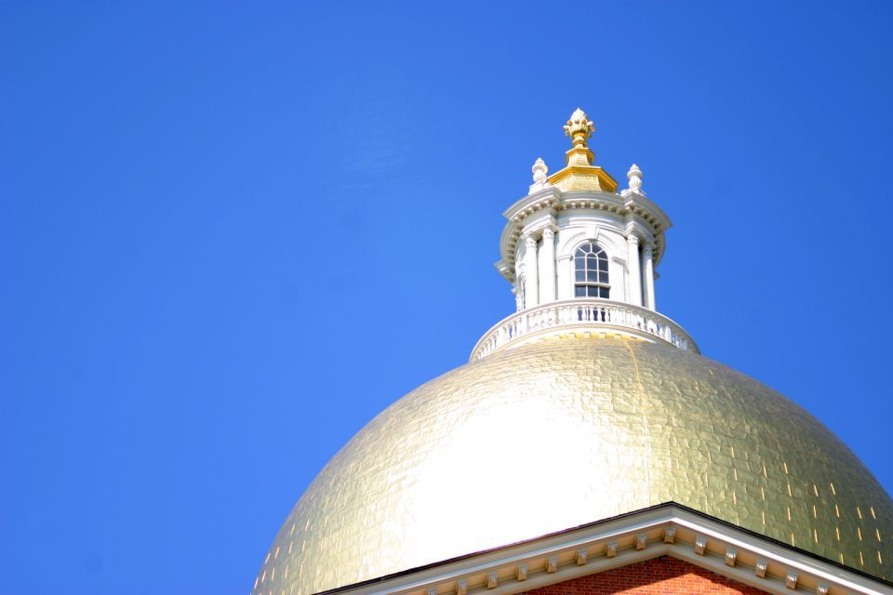  6 | 7
 |  |  |  |  | Student Gov’t Day @ State House
8 | 9  Spirit Week | 10  Spirit Week | 11  Spirit Week | 12  Spirit Week | 13 | 14
 | MCAS ELA (Middle School) | MCAS ELA (Middle School) | MCAS ELA Make-up  (Middle School) | Field Trip (Fuller Museum) | Yoga Guest Instructor (11-12:30)
15 | 16  V A | 17  C A | 18  T I | 19  O | 20  N | 21
22 | 23 | 24 | 25 | 26 | 27 | 28
 |  | SEAPERCH Competition @ Connell Rink (Weymouth) | MCAS MATH (Middle School) | MCAS MATH (Middle School) | MCAS MATH Make-up  (Middle School)
29 | 30

SPIRIT WEEK Physical Fitness. Monday-Thursday staff and students will do one exercise during
Read block

