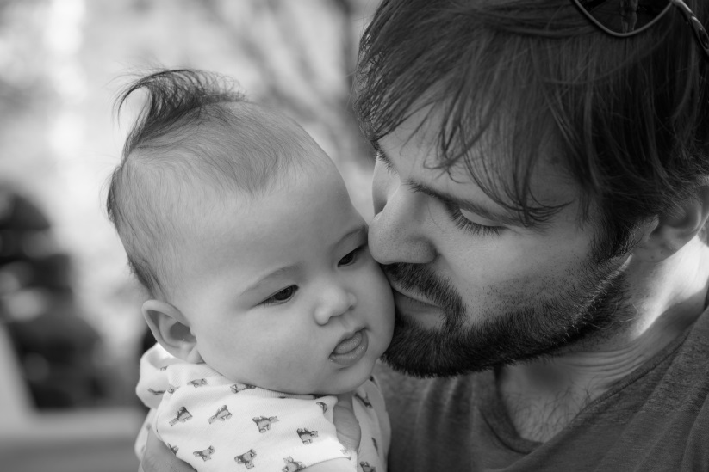

New Dads' Group
For expectant fathers & dads of babies under a year
Make connections with other fathers, ask questions, exchange tips, and share your experience of parenthood and all the changes it brings with it. Fathers welcome to attend with or without babies. Facilitated by Heather O'Brien, LICSW.

Groups held monthly on Tuesday Evening
7:00-8:30 P.M.
Register to receive a monthly email reminder with discussion topic: 978-429-8284 or hobrien@jri.org
First Connections serves families in the communities of Acton, Bedford, Boxborough, Carlisle, Concord, Harvard, Lincoln, Littleton, Maynard, Sudbury, and Westford as a Mass Dept. of Early Education & Care Coordinated Family & Community Engagement grant recipient and receives additional funding from the Community Chests of Concord Carlisle, and Maynard;
the Acton-Boxborough United Way; and individual donations. www.firstconnections.org

