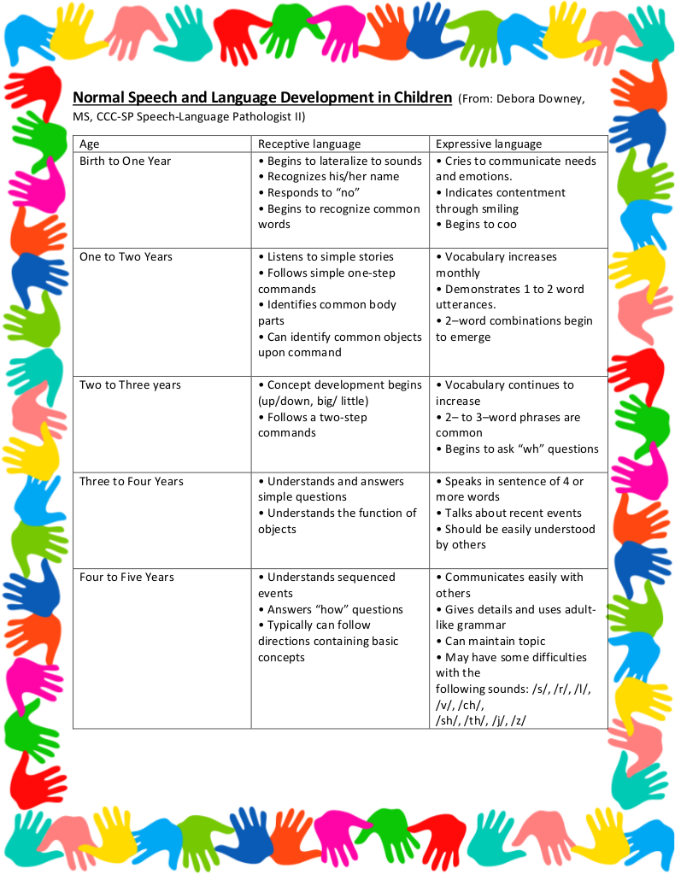
communication Milestones For Ages 1-4
Thursday, November 8, 10:00-10:45
Presented by Speech-Language Pathologist Emma Hill
Held at Concord Carousel Preschool
Communication between you and your child, as well as your child and family members or caregivers, looks very different at one year old than it does at four years old. Join Emma as she outlines the typical milestones for each age group as well as ways you can help your child’s vocabulary grow. She will also let parents know what red flags would signal need for an evaluation.

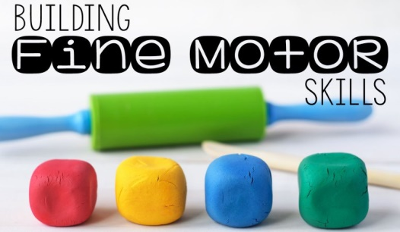
Fine Motor Milestones & School Readiness
Tuesday, December 18, 10-11:30
Presented by Occupational Therapist Chelsea Mello, and Sharon Ryan, Elementary Literacy & Social Studies Curriculum Specialist
Held at First Connections, Acton
Join us for an overview of fine motor milestones in toddler- and preschool-age children from 10-10:30, followed by Sharon’s presentation on how the development of fine motor muscles is a necessary skill for school readiness.

These programs are free of charge. Childcare is available, with reservations, provided by our staff while parents meet with the presenter in a separate room. Infants can stay with parents.
If you need childcare, or if you would like to attend, please let Linda know so that we have enough handouts and space for your child if needed: lmatthews@jri.org

