February | “The Boy Who Harnessed the Wind”
2019 | 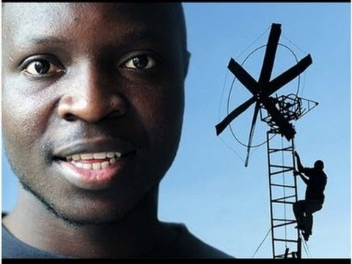
 | William Kamkwamba

Sunday | Monday | Tuesday | Wednesday | Thursday | Friday | Saturday
 |  |  |  |  | 1 | 2
Basketball Game @ Victor School
(11:00)
3 | 4 | 5 | 6 | 7 | 8 | 9
 | Basketball practice (2-3 pm) |  | MCAS BIO (HS) | MCAS BIO (HS)
10 | 11 | 12 | 13 | 14 | 15 | 16
 | MCAS BIO (HS) Make-Up  Basketball practice (2-3 pm) |  |  |  | Early Release  (12 pm)  School Assembly (West 1 Hosts)
17 | 18 | 19 | 20 | 21 | 22 | 23
24 | 25 | 26 | 27 | 28
 | Last Basketball Practice  (2-3 pm) |  | Guest Speaker: William Kamkwamba (11:30-1:00)

*February is LITERACY MONTH. We encourage all students and staff to read as much as possible!
https://www.youtube.com/watch?v=G8yKFVPOD6o

