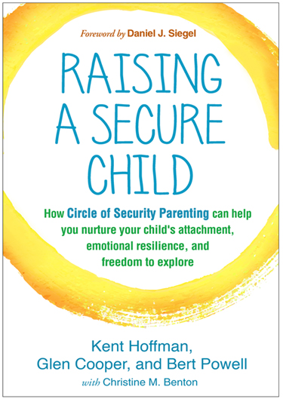
CIRCLE of SECURITY:
A Parenting Education Series for Parents of Children 0-5 yrs old
8 TUESDAYS: April 2, 9, 23, 30, May 7, 14, 21, 28
Facilitator: Carolinda Sterczala, MSW, LICSW, BCN
Location: First Connections, 179 Great Road, Acton MA
Cost: Free of charge
PRE-REGISTRATION IS REQUIRED (as spots are limited!): To register, email Linda at LMatthews@jri.org and type “Circle of Security” in the subject line.

Most families seek to promote enjoyable and connected relationships with their kids. But what does that look like? At times all parents wonder what our child might need from us. Imagine what it might feel like if you were able to make sense of what your child was really asking from you. The Circle of Security® Parenting™ program is based on decades of research about how secure parent-child relationships can be supported and strengthened.
Using the COSP™ model, which includes graphics, DVD chapters, handouts and discussion, parents and caregivers work to:
- Understand their child’s emotional world by learning to read emotional needs
- Support their child’s ability to successfully manage emotions
- Enhance the development of their child's self esteem
- Honor the innate wisdom and desire for their child to be secure

Learning about our children’s needs can be enjoyable as well. Often “the circle” helps us makes sense of the needs that have been “hiding in plain sight”. Other times the needs are known, but it is still nice to be able to put some simple language or visuals on the attachment needs our kids have while they are exploring or coming back to us for comfort.
While COSP™ is designed for parents and caregivers of kids 0-5, the connection and exploration doesn’t go away after that. Carolinda enjoys watching the variations of the circle through kids’ growing up years and beyond.
During the eight-week group we will strive to create a supportive environment for seeking enjoyable and good enough parenting, not perfection! Since the program builds progressively on the prior week’s discussion topics, we are asking participants to make a commitment to attend all dates in the series unless unexpected illness interferes with that plan.
About our presenter: Carolinda graduated with her MSW in 2000, and since then has had various positions offering outpatient therapy to adults in Massachusetts, including past roles as Clinical Director of an Outpatient Counseling Center and DBT Program Coordinator. She currently has a Private Practice in Concord. She is current President of the New England Society of the Treatment of Trauma and Dissociation.
This 8-part series is free to participants and is offered in collaboration with the Center for Parents and Teachers and First Connections.
Childcare: This group is for parents and caregivers only. Experience has taught us that participants don’t tend to be able to absorb the material when there are kids of any age in the room with them – whether your own children or someone else’s.
If you do not already have child care or a babysitter your child is familiar with (the best option), First Connections’ staff can provide childcare in the playroom during the program. Children using this service should be able to successfully separate from their caregiver and families should arrive early to make this a smooth process. Childcare is free of charge, but please let us know the age and first name of children needing care when registering. Childcare providers are CORI’d and you can see your child from the group room. If your child may get hungry during the group, please feel free to bring along lunch for them.
Learn about other programs offered by the Center for Parents and Teachers at www.centerforparentsandteachers.org
Learn more about other programs and resources offered by First Connections at https://jri.org/services/foster-adoption-ecs/first-connections

