May
2019 | 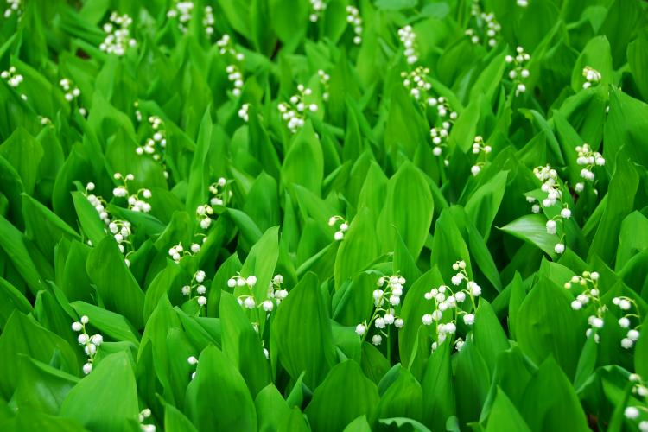

Sunday | Monday | Tuesday | Wednesday | Thursday | Friday | Saturday
 |  |  | 1 | 2 | 3 | 4
 |  |  | MCAS Makeup-MS Math |  | Picture Day!
5 | 6 | 7 | 8 | 9 | 10 | 11
 | FAST (2:00-3:00) |  | College and Career Fair | Mathlete Competition
12 | 13 | 14 | 15 | 16 | 17 | 18
 | MCAS- MS STE  FAST (2:00-3:00) | MCAS- MS STE | MCAS Makeup: MS STE |  | 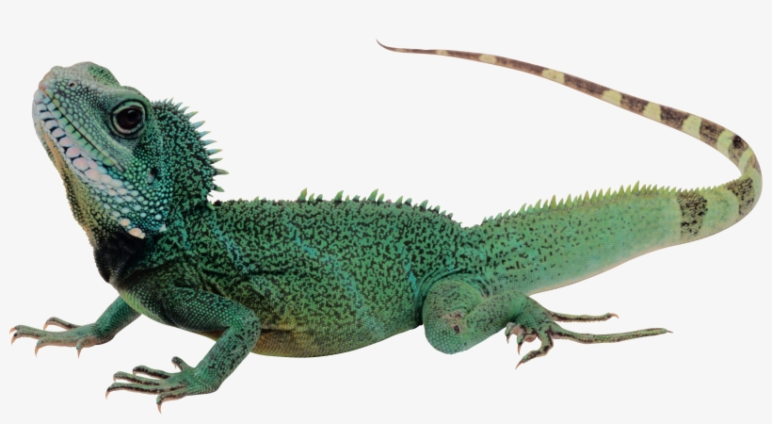  Live Reptile Show!
19 | 20 | 21 | 22 | 23 | 24 | 25
 | Ice-Cream Parlor Day | MCAS Math  10th Grade | MCAS Math  10th Grade | MCAS Math  10th Grade
26 | 27 | 28 | 29 | 30 | 31
 | NO SCHOOL |  | Graduate Panel (9:30-10:30)  PAC Meeting (10:30) | MCAS Makeup  10th Grade

