PAC / Parent Workshop Series / Parent Events
2019 – 2020
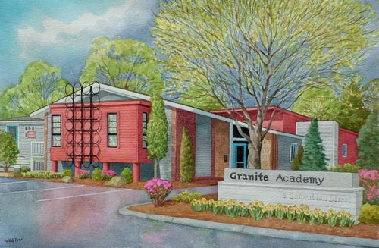
Tuesday September 24 | 5:00-6:30 | Night of Excellence | Gym
Wednesday October 30 | 9:00-10:00 | Cider House | Gym
Wednesday October 30 | 10:00-11:30 | PAC meeting  “TRS for Parents”  Scott McGinn | West Conference Room
Wednesday December 4 | 10:00 - 11:00 | PAC meeting | West Conference Room
Wednesday January 22 | 9:00-10:00 | Poetry Slam | Gym
Wednesday January 22 | 10:00-11:30 | PAC meeting  Google Classroom  Tatyana Rozenblyum | West Conference Room
Wednesday February 12 | 10:00-11:00 | PAC meeting | West Conference Room
Wednesday March 18 | 10:00 - 11:00 | PAC meeting | West Conference Room
Wednesday April 29 | 9:00-10:00 | Café (talent show) | Gym
Wednesday April 29 | 10:00-11:30 | PAC meeting  Skills 4Living/Transition programming  Kathy Callahan | West Conference Room
Wednesday May 27 | 9:00 – 10:00 | Graduate Panel | Gym
Wednesday May 27 | 10:00–11:30 | PAC meeting  Parent Choice | West Conference Room

