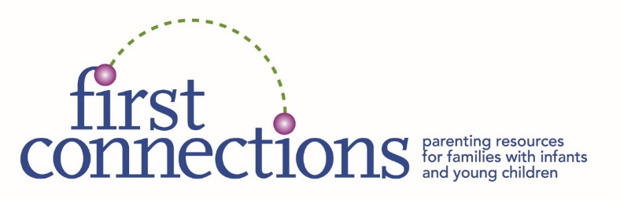
One-Time
FAMILY REGISTRATION FORM

Demographic and diversity questions are voluntary. The data collected is only used collectively for the purposes of grant applications and reporting. Our program is entirely grant- and donation-funded. We never share individual names with any government entity. *
PARENT/CAREGIVER #1_______________________________Gender identity:____________________________
___Black ___Asian ___Hispanic ___White ___Native American ___Haitian Other_________________
___Single ___Teen ___Adoptive parent ___Grandparent/kinship parent Disability?___Yes___No
PARENT/CAREGIVER #2_______________________________Gender identity:____________________________
___Black ___Asian ___Hispanic ___White ___Native American ___Haitian ___Other_____________
___Single ___Teen ___Adoptive parent ___Grandparent/kinship parent Disability?___Yes___No
LANGUAGE(S) SPOKEN AT HOME:_______________________________________________________________
Postal Mailing Address:__________________________________________________________________________
Email Address:________________________________ Primary Phone #:_________________________________
CHILDREN: I am due to deliver or adopt: Month______ Year______
Child Name #1: ______________________ Birth Month______ Year______ E.I. or IEP?__ Yes___No
___Black ___Asian ___Hispanic ___White ___Native American ___Haitian Other________________
Child Name #2: ______________________ Birth Month______ Year______ E.I. or IEP?___Yes___No
___Black ___Asian ___Hispanic ___White ___Native American ___Haitian Other_______________
Child Name #3: ______________________ Birth Month______ Year______ E.I. or IEP?___Yes___No
___Black ___Asian ___Hispanic ___White ___Native American ___Haitian Other________________
Please return this form in any of the following ways:
Mail: First Connections, 179 Great Rd., #104A, Acton, MA 01720
Fax: 978-429-8690 Scan/email: lmatthews@jri.org

First Connections is funded primarily by a Coordinated Family & Community Engagement Grant from the Mass. Dept. of Early Education and Care.

*Please note: In accordance with The Child Abuse Prevention and Treatment Act of 1974, and Massachusetts General Laws, Chapter 119, First Connections’ staff, as employees of Justice Resource Institute, are mandated reporters and must report all cases of suspected child maltreatment to the Department of Children and Families.

