Helping with Day-to-Day Challenges

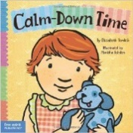
Calm Down Time, by Elizabeth Verdick – diffuse tantrums
This picture book leads toddlers through evidence-based exercises designed to diffuse tantrums: deep breathing, reciting calming phrases and counting numbers out loud. Kids are meant to absorb the lessons and learn to use them as self-soothing techniques when they feel their emotions getting out of control. "One, two, three...I'm calm as can be." Parents of explosive tots give the book high marks.

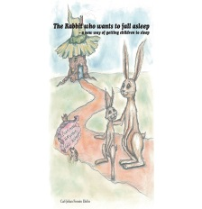
The Rabbit Who Wants to Fall Asleep by Carl-Johan Forssen Ehrlia - easing bedtime battles. Experts have compared the book to a form of “gentle hypnosis,” written with sleep-inducing cadences and employing cues like loud yawning. The groundbreaking #1 bestseller is sure to turn nightly bedtime battles into a loving and special end-of-day ritual. This child-tested, parent-approved story uses an innovative technique that brings a calm end to any child’s day.
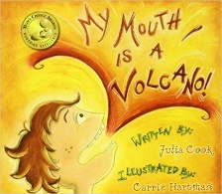
My Mouth is a Volcano, by Julia Cook – controlling verbal interruptions
In this wonderful book about learning to control your words until the appropriate moment, a young boy has a hard time controlling what he wants to say and at many times is disruptive. He begins to see things differently when a few interruptions happen to him!

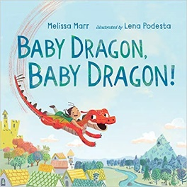
Baby Dragon, Baby Dragon, by Melissa Marr – learning to calm down
Many parents will identify with this active little dragon who has a little trouble being calm and quiet. With a little guidance and encouragement, the little dragon learns how enjoyable life can be if he learns to manage his overexcited actions.
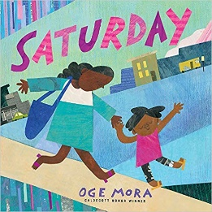
Saturday, by Oge Mora – coping with disappointment
Ava’s mother works every day except Saturday, so this is their “cherished” day of adventure together. Unfortunately, things don’t go as planned – storytime is canceled, and they leave their tickets to the puppet show at home. The theme of togetherness and coping when things go awry teach children that memories of things they do can still last a lifetime even if it’s not what you thought it would be.

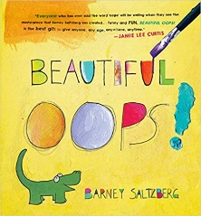
Beautiful Oops, by Barney Saltzberg - it’s okay to make a mistake
Not only do mistakes happen, but some amazing things can be created with an “oops.” In this book we see several art projects that have gone awry but how with some imagination and creativity these mistakes became something really amazing.

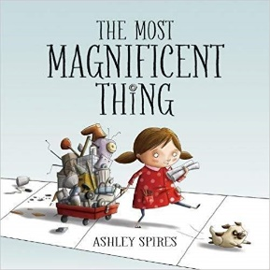
The Most Magnificent Thing by Ashley Spires – handling frustration
A story about a girl and her best friend (a dog), and her attempts to make something she can see in her head but it’s not as easy as she thought it would be to make it, leaving her really mad and frustrated! The book offers good options for dealing honestly with these feelings.

Understanding Emotions

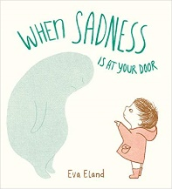
When Sadness is at Your Door, by Eva Eland – it’s okay to be sad
Sadness appears as a soft blue blob at a little child’s door one day. We do not know why it came or how long it is going to stay, but it just showed up. The story explains that when this happens it is best to just let sadness in, ask sadness to sit down, and spend a little time with sadness. It is a great way to show children that it is acceptable to be sad and it is nothing to reject or fear.

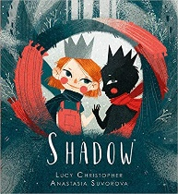
Shadow, by Lucy Christopher – when a parent is sad
This book deals with the sadness of a parent. In the story a young girl and her mother have relocated to a new home. The reader does not know the backstory but we do know that the mother is sad. We then see the way the little girl works through this and how eventually she and her mother learn to find happiness again.

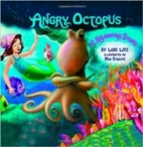
Angry Octopus, by Lori Lite - manage stress, anger, anxiety This colorful book teaches kids the basics of progressive muscle relaxation (think: relaxing your whole body starting with your toes and moving upwards) and deep breathing with pictures of an octopus that inflates and deflates. Written by a stress expert, it promises to help kids manage stress, anxiety and anger. Research has shown that relaxation techniques like progressive muscle relaxation and deep breathing reduce symptoms of many ailments, from depression to insomnia to chronic pain.

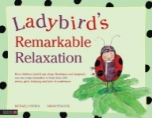
Ladybird's Remarkable Relaxation, by Michael Chissick – manage stress, fear, sadness. Ladybird has a remedy for Frog's stress over chores, Flamingo's fear of bullies and Dragon's sadness about his grandpa dying. Yoga! She leads the animals through what yogis will recognize as yoga nidra, or yogic sleep, a progressive relaxation technique with copious scientific evidence for its benefits. The book is designed to “calm busy minds and young nervous systems,” giving kids a relaxation technique they can later use.
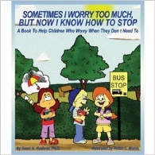
Sometimes I Worry Too Much, But Now I Know How to Stop, by Dawn A. Huebner – calm the worries. Little Anna used to worry herself sick over everything. Would her friends want to play with her at recess? What if she didn't do well on a test? Her dad told her “don’t worry, be happy,” but that didn’t work. Instead, the book takes Anna through simple, evidence-based cognitive behavioral techniques for reducing worry, teaching her that when you focus too much on a scary thought, you allow it to grow. Written by a clinical psychologist, it’s meant for kids ages 5 to 10.
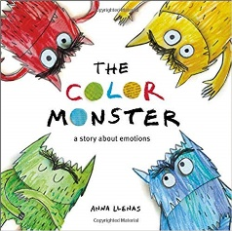
The Color Monster: A story about emotions, by Anna Llenas – identifying different emotions. This book is a great tool for children to handle the many emotions they might experience-all seen through the story of a little girl helping a monster who is experiencing a variety of emotions.

Siblings & Friends with Autism
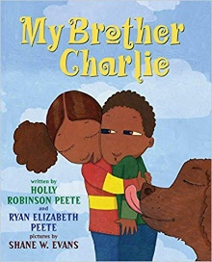
My Brother Charlie, BY Holly robinson Peete & Ryan Elizabeth Pete
A young girl explains what life is like with her autistic twin brother. We see how sometimes things are good but sometimes it can be confusing – words locked in his mouth or gestures of affection not expressed. As the young girl says, “I have learned from Charlie that love doesn’t always come from what you say. It can also come from what you do.”

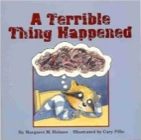
A Terrible Thing Happened, by Margaret M. Holmes – after traumatic events
Raccoon Sherman Smith sees an unnamed “terrible thing” happen one day. Afterwards, he has tummy aches, nightmares and nervous spells. But Ms. Maple, his school counselor, encourages him to talk about what he saw and draw pictures. This book is designed for kids who have experienced trauma, from physical abuse to natural disasters. It works with the principle that avoidance is detrimental to mental health, as trying to suppress trauma will only cause trouble in other areas of a person's life.

http://www.smithsonianmag.com/innovation/six-childrens-books-that-use-psychological-techniques-help-kids-180956378/?utm_source=mentalfloss&no-ist

