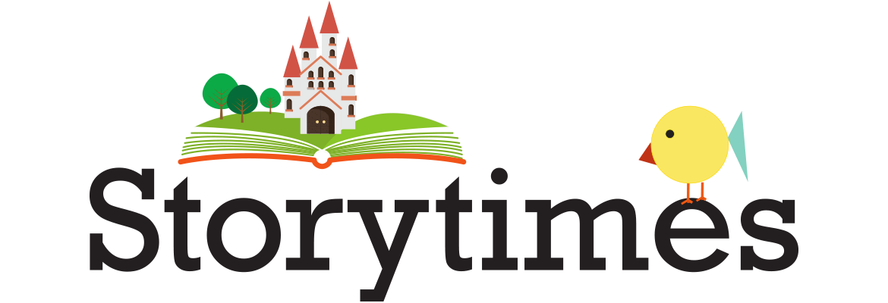
Winter
2021

Acton Memorial Library, www.actonmemoriallibrary.org
Lapsit Storytime via Zoom will take place on Tuesdays, 10-10:30 for ages 0-36 months with a grownup. Includes rhymes, reading stories, songs and fingerplays to encourage a love of reading. Held 1/5-3/23.
Preschool Storytime will meet on Thursdays, 10-10:45, with Elise for lively singing, fingerplays and wonderful stories.
Craft Together Group meets on Thursdays, 4:30-5:00. Pick up supplies weekly, them join the group to make your craft. Held 1/7-3/25. All groups are free and require registration on the calendar to receive the Zoom links:
Events Calendar | Events & Programs | Acton Memorial Library

Bedford Public Library, www.bedfordlibrary.net
This library has a monthly virtual Homeschool Book Club open to all, whether homeschooling typically or temporarily. Two age groups: 8-11 and 12+, where kids read an assigned book (available on Hoopla) and discuss it.
Virtual storytime for all ages will be held on Wednesdays at 10:30 with Miss Bethany & Miss Elaine. Link is here:
Zoom Storytime - Bedford Free Public Library (bedfordlibrary.net)
Alphabits for Ages 2-5 meets Mondays at 10:30. Register here for the storytime link and a printable craft each week:
Alphabits - Bedford Free Public Library (bedfordlibrary.net)
Monthly Saturday Flower Yoga & Mindfulness class for children in K-2nd grade. Held 10:30 thru March 20. Register:
Children's Yoga and Mindfulness (virtual) - Bedford Free Public Library (bedfordlibrary.net)

Sargent Memorial Library, Boxborough, www.boxlib.org
18 mo. to Pre-K storytime meets Mondays at 3:30 and Tuesdays at 11:00.
Pre-K & Older storytime meets Tuesdays at 4:00. Zoom meeting codes and passwords here:
Programs and Events | Services | Sargent Memorial Library (boxlib.org)
Spanish Lessons available here: Spanish Lessons with Mrs. R | eResources | Sargent Memorial Library (boxlib.org)

Gleason Library, Carlisle, www.gleasonlibrary.org
Storytime for ages 3-6 will be held on Wednesdays, 10-10:40 thru March 14. Register to receive the link:
01/13/2021 | Winter Preschool Story Time Online | Gleason Public Library (assabetinteractive.com)

Concord Public Library, Event Calendar | News & Events | Concord Free Public Library (concordlibrary.org)
Zoom Storytime with Royce for Preschoolers will be held on Wednesdays from 10-10:30. Register on the library calendar.
Zoom Storytime with Dorrie for Ages 5 and under will be held Thursdays, 10-10:30. Register on the library calendar.
Family Singalongs with Ed Morgan at 10:00 on Jan. 22, Feb. 19 and Mar. 19 Register on library calendar.
Rockabye Beats held at 10:00 on Jan. 27, Feb. 24 & Mar. 31. Register on library calendar.
Nature Connection for Ages 3-6 at 10:30 on Jan. 19, Feb. 16 & Mar. 16. Register on library calendar.
Nature Connection for Ages 6-10 at 4:00 on Jan. 20, Feb. 17 & Mar. 17. Register on library calendar.

Harvard Public Library, https://www.harvardpubliclibrary.org/services/events
Mother Goose on the Loose for ages 0-2 will be held on Mondays and Thursdays at 10:30. The program includes rhymes, songs, music, movement, ritual, repetition, positive reinforcement, developmental tips, nursery rhymes, puppets and stories to help children develop a love of book reading.
2 & 3 Year Old Storytime will meet on Wednesdays at 10:30. Includes songs, stories, feltboard, creative dramatics and fingerplays. 4-7 Year Old Storytime will meet on Mondays at 1:30 and includes longer picture books.
To receive the connecting link for any storytime, register here:
HPL Virtual Storytime Registration Form (google.com)

Reuben Hoar Library, Littleton, LibraryInsight (children’s calendar)
The library now has a special Facebook page for children’s posts and story times. RHL Children's Page | Facebook
“Littles & Letters” Storytimes will be held on Wednesdays for ages 3-5. Sign up on calendar for reminders.
Toddler Story Times for ages 18-36 months will be on Fridays mornings.

Lincoln Public Library, http://lincolnpl.org/
Email sfeather@minlib.net to receive the zoom link for All Ages Storytime at 10:00 on Tuesdays.
Email dleopold@minlib.net to receive the zoom link for Ed Morgan Sing-a-longs on Jan. 8, Feb. 5, Mar. 5, Apr. 2 at 10:30.

Maynard Public Library, https://www.maynardpubliclibrary.org/
Children’s storytime programs are taking place via zoom, but the website page and registration forms have not been updated for the winter session yet. Fill out this email request for current new info: Children's E-mail List (google.com)

Goodnow Library, Sudbury, https://goodnowlibrary.org/calendar/, Goodnow Library - Home | Facebook
All programs are held on Facebook Live and do not require pre-registration: Mondays-Music Makers for ages 0-5, 10:30-11, Wednesdays-Wee Reads for 0-18 mos from 10:30-11, Thursdays-Tales for Tots 18 mos-3 yrs from 10:30-11, Fridays-Preschoolers 3-6 yrs from 10:30-11

J.V. Fletcher Library, Westford, https://westfordlibrary.org/, 978-399-2302
Please send a request to join the private J.V. Fletcher Library Youth Services Department Facebook page to see all kinds of other fun posts and news from your friends in Youth Services. Registration for storytimes begins Jan. 11, 6:30.
Mother Goose Storytime on Thursdays at 10:30 starting January 21.
ABC & Me on Tuesdays at 10:30 beginning January 26.
For information and registration for Rockabye Beats on January 13, or to sign up for book/craft bundles, see more information here: Kids Programs - J.V. Fletcher Library (westfordlibrary.org)

